

Operating Systems Lab 5

ITSC 200: Network Protocols and Security

Table of Contents

Lab Outcome(s) 2

Reading 2

Introduction 2

1.0 Practice using basic Linux shell commands in the shell and in a shell script 3

References 4

Lab Outcome(s)

* Gain familiarity with the Linux (Bash) command line and bash shell scripting.

Reading

* Linux_cheatsheet_1

Introduction

This lab is to familiarize you with using shell commands and Bash shell scripts in a Linux environment. We will use a virtual instance on the Cybera Cloud but you can also practice this lab at home on your laptop as well.

1.0 Use basic Linux commands

1. Login into your VM on the Cybera Cloud. Open a Terminal window.
2. You will see a window, as below.  
     
   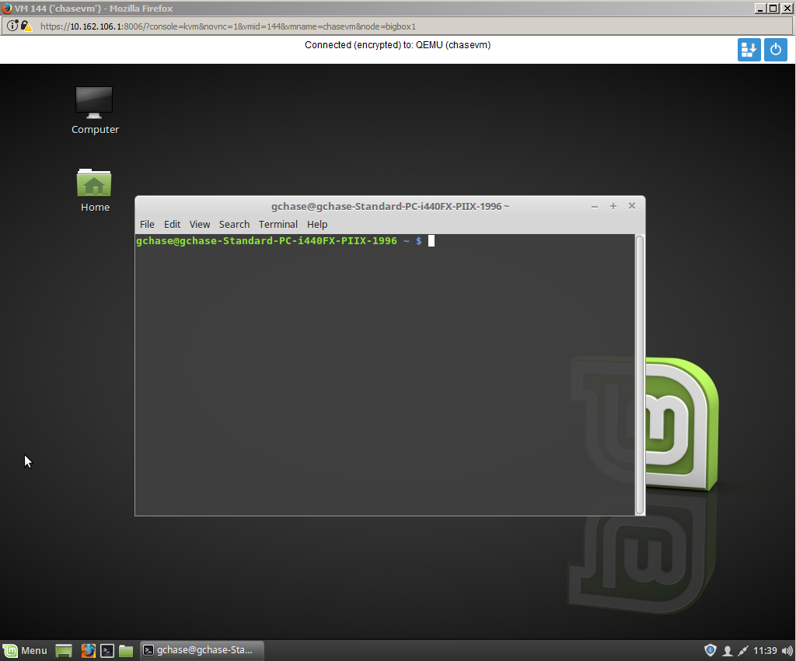
3. Using an editor of your choice, create a script that will print the following to your screen when you run it. It doesn’t have to be exactly the same but should be very close. Make sure that you use environment variables to print out the name of the user and the host name.
4. Use the “set” command to see all of the environment variables that are set in your current login. Use those environment variables to create a small Bash script that will produce the following output on the screen (using your username and machine name of course) :

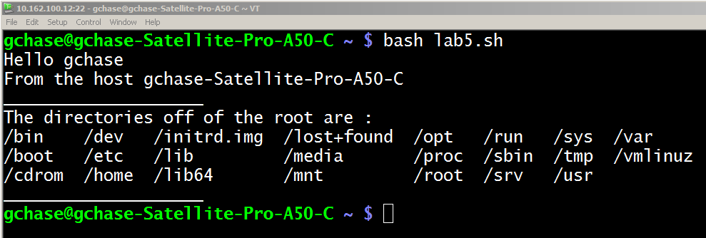

1. Create a small script to find all of the files on your computer that are larger than 100 Mb in size. Write the output to the screen.
2. Submit both scripts, along with a screen shot of the output when they are run, to the OS Lab Assignment folder in D2L (Brightspace).

References

Linux_cheatsheet_1

Blank page if necessary to make pages an even number

**DO NOT DELETE THE SECTION BREAK BELOW. DELETING IT MAY IMPACT THE FORMATTING IN THIS DOCUMENT.**